AWS Kinesis Overview:

- Kinesis is a managed alternative to Apache Kafka.
- Great for application logs, metrics, IOT, Clickstreams
- Great for “real-time” big data
- Great for streaming processing framework (Sparks, Nifi etc..)
- Data is automatically replicated synchronously to 3AZ.

- Kinesis Streams – low latency streaming ingest at scale
- Kinesis Analytics – perform real time analytics on streams using SQL
- Kinesis Firehouse – Load streams in S3 ,Redshift , Elasticsearch and splunk

Kinesis -

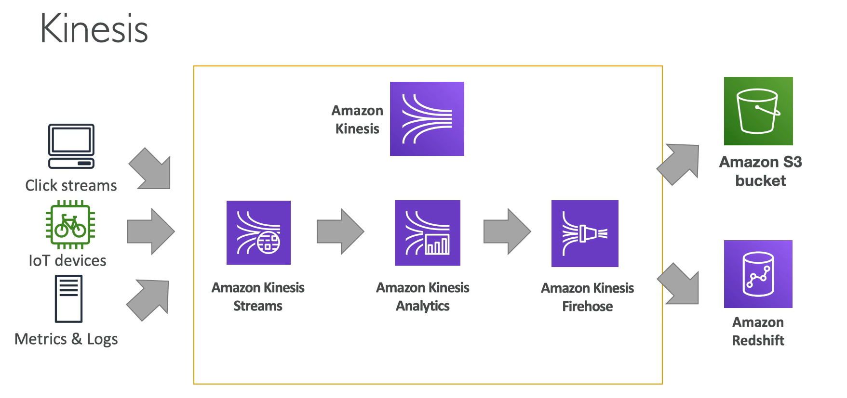

Kinesis Streams Overview -

- Streams are divided in ordered shards and partitions
- Data retention is 24 hours by default and can go up to 365 days
- Ability to reprocess/replay data
- Multiple applications can consume the same stream
- real time processing with scale of throughput
- once data is inserted in kinesis, it can’t be deleted (immutability)

Shards -

- Once stream is made of many different shards
- billing is per shard provisioned , can have as many shards as you want
- batching available or per message calls
- the number of shards can evolve per time (reshard/merge)
- Records are ordered per shard
Kinesis Stream records -

- Data blob – data being sent , serialized as bytes. Upto 1 MB . Can represent anything
- Record key – sent alongside a record , helps to group records in shards . Same key = shard. Use a highly distributed key to avoid the “hot partition” problem
- Sequence number – Unique identifier for each records put in shards . Added by Kinesis after ingestion.

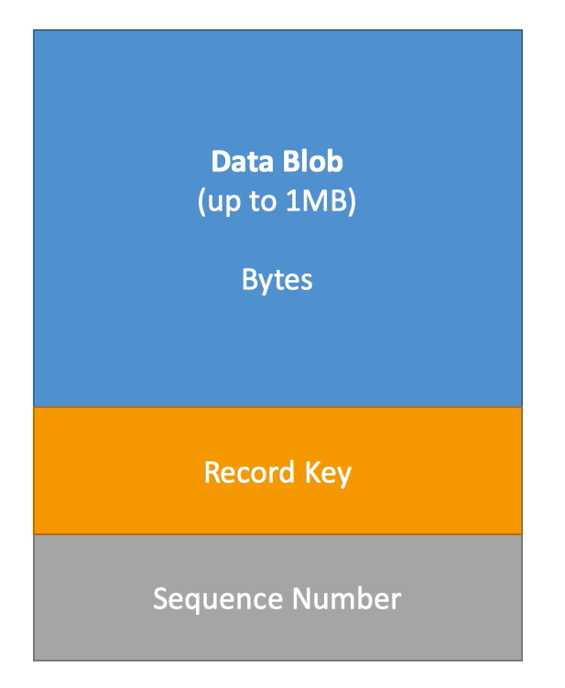

Kinesis Data streams limit to know:

Producer -
- 1MB/s or 1000 message/s at write per shard
- “ProvisionedthroughputException” otherwise

Consumer Classic -
- 2MB/s at read PER SHARD across all consumers
- 5 API calls per second PER SHARD across all consumers

Consumer Enhanced fan-out -
- 2MB/s at read per shard, per enhanced consumer
- No API calls needed(push model)

Data retention -
- 24 hours data retention by default
- can be extended to 365 days

